桌面影像式扫描器快速指引
Programming User’s Manual
Ver:1.0

更多功能请与销售商联系
Please contact the seller for more functional settings
注意事项/Warning
- 扫描器的工作电压是5V，在扫描器与设备进行连接前，应仔细检查电源的额定电压。特别是使用RS232电缆线时外接变压器的电压。
Please use the 5V power adapter .The power adaper must to meet the safety standards.
- 远离热源，保持通风。
Keep away from heat sources.
- 在存储、运输和运行环境中注意防水。
Pay attention that the scanner is waterproof during storage,transportation and running.
- 扫描平台使用时照明灯光线较强，请勿直视或对准眼睛，以免造成不适或者伤害。
The scanning platform when using a strong light lamp, do not aim at eyes, so as to avoid discomfort or damage to the eyes

物品清单/Parts list：
扫描器/Barcode Scanner X1
USB电缆线/USB cable X1
快速指引/Quick start guide X1
合格证与保修卡/ Certificate and warranty card X1

外观及功能/ Appearance and function
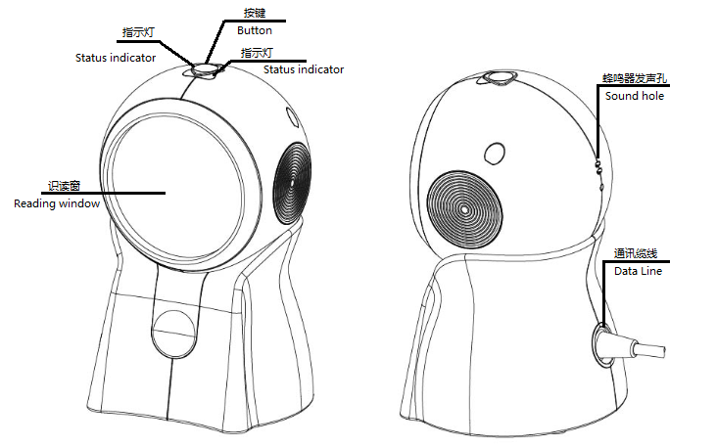
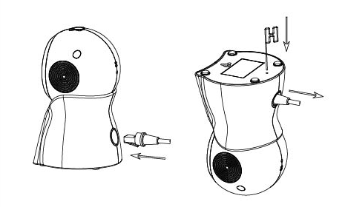
USB缆线的装配和拆卸/ The installation and removal of cable
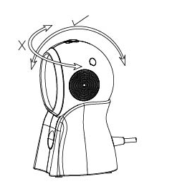

扫描窗口可以上下调节，但不能左右调节。
The scanning window can be adjusted up and down, but it can not be adjusted to the left and right.

按键/Button
打开和关闭白光照明LED/Open or close the white light illumination LED
指示灯和蜂鸣器/LED indicators and beeper
状态/ state 响应/ response
接通电源 红灯亮，蜂鸣器响四声
Power on Red LED on(always),Four short beep

断开电源 红灯灭
Power down Red LED go out

工作状态或者待机状态 绿灯亮
State of operation and standby Green LED on(always)

扫描条码成功 绿灯闪烁一次，蜂鸣器响一声
Good read Green LED flashes one time. One short beep

设置/Setting:
备注：带*号的为出厂默认设置。
Note: The default settings of the factory have the * sign

语言键盘设置/ Language keyboard Setting
(默认美语，中国用户也适用此默认设置)
*美国/US 捷克/CZ
法国/French 德国/Germany
匈牙利/Hungary 意大利/Italian
日本/Japan 西班牙/Spanish

终止符选择/ Select Terminator

CR/回车*

None/关闭结束符
TAB/跳格
CRLF/回车+换行

条码制式选择/ Symbologies Selection
禁止识读PDF417码制和禁止识读DM码制将会提高解码速度。
允许识读DM/ DM ON
禁止识读DM/ DM OFF
允许识读PDF417/ PDF417 ON
禁止识读PDF417 /PDF417 OFF

